This is my first webpage!!

“Anything which helps the aspiring developers and beginners who’re learning to code”

Login page of my webpage expedition:

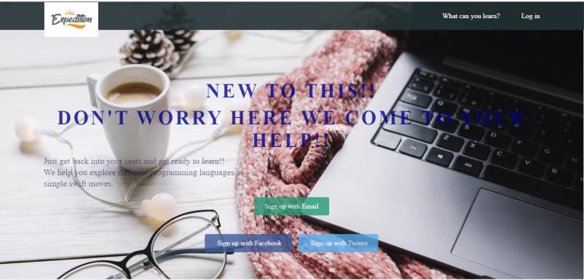

The lessons to be learned section that gives you a idea what are programming languages and what you can learn:

